Département Technique IESN BAC3

Sections AU, IG, IR, TI Anglais Renforcement 2023-24



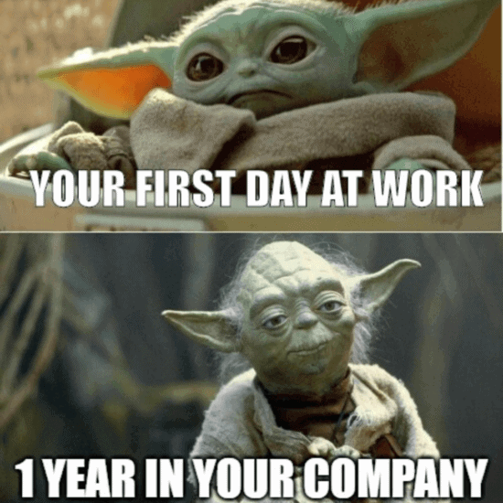

Chapter 1 : Introduction to the World of Work

Justine De Witte

Stéphanie Hayen

Ophélie Kruyts

(+ special thanks to Laurence Léonard)

In this first chapter, we are going to see an introduction to the ***World of Wor******k***, which means that we are going to speak about:

Companies & Bosses

1. **Companies**
2. What comes to your minds when we speak of « companies »? What is a company? What do you need to be called « company »?

* It’s an organization that aims to making money.
* Synonym = Enterprise, society, firm.

1. How do you see your future company, what does it need to have or give you?

* Money 🡪 monthly (hourly) wage/salary
* Independent = income, bill, invoice, receipt

1. What do you expect from your future company?

* Advantages = vacation
* Stable/positive/non-toxic workplace environment/atmosphere

1. Employed vs Self-employed (independent). List the advantages and disadvantages of both.

(+)

* You make your own schedule.
* You have no manager/boss 🡪 you are the only CEO (chief executive officer)
* If you own a successful business, you can earn quite a lot of money.

(-)

* You get no help from the state
* No stability when it comes to money
* No fixed holidays/vacations.

1. Who would like to be self-employed? Why? And why not for those who don’t want that?

* Depends on your business plan.
* Depends on your background and personality

1. What is the best company according to you and why?

Odoo, Google.

1. **The World’s Best Boss**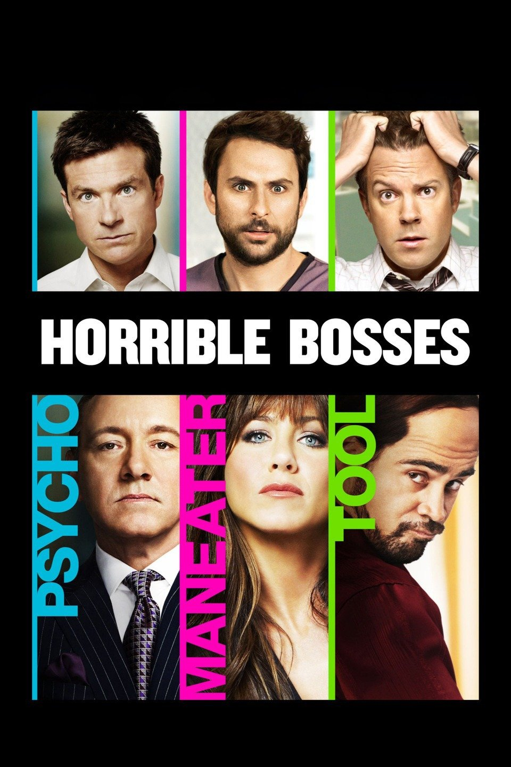

* ***Speaking***

1. According to you, how do you have to behave and act to be considered at least a « good » boss?

* Help your employees 🡪 be knowledgeable, be good enough to answer your employees questions
* Behavior 🡪 shouldn’t overreact passive naïve should be strict enough.
* Boss = friends? More friendly then really friend (what happens when you need to fire them)

1. Who is, in your opinion, the best boss? Why ? What is the best boss like?

* Money + vacation
* Recognition: Employee of the month (sometimes they may get a bonus)
* Benefit = hierarchy (promotional aspect, i.e. become a manager)

1. Do you know famous bosses? Name a few of them.

* Bill gates, Mark Zuckerberg, Elon Musk, Steve Jobs.

1. Have you ever heard of Gravity Payments?  
   What could it be?  
   Who is this man? Would he be an employee or the CEO ?

|  |  |
| --- | --- |
| Image | Image |



* ***Watching a video***

***America’s best boss* 🡪**https://www.youtube.com/watch?v=ZLAKJM5AznA

**Watch the video and answer the following questions in English. (0:42 – 2:05)**

1. What do you get to know about Dan PRICE?

* -  Age: 30 years old
* -  Job/Function: CEO
* -  Company name: Gravity payments
* -  Kind of company: Product? Service? Payments
* -  Location: Seatle
* -  Staff: 120 persons

1. What will happen to every worker?

They will be paid 70K a year 🡪 everyone working for gravity Payments will earn the same amount of money (there will be no wage gap)

1. Why did Dan Price make such a decision?

To be competitive regarding other companies 🡪 productivity and keep your employees close.

1. What will that allow them to do?

Because Dan Price cut is own salary

1. How much did he earn?

A million

1. How much will he earn?

70k a year

1. How did he come to this idea?

He doesn’t really answer, he can go a few years without with out is full salary.

1. His motivation is deeper. Explain.

He wants to keep is employees close + maybe did it for fame

1. Fill in the gaps:  
   “*His critique of income disparity is just the latest in a cacophony of voices that have been sounding the alarm on the growing gap between rich and poor as it reaches unprecedented levels*

* ***Conclusion***
* So now you know, what do you think of this guy?
* Do you have other great ideas that you could try, if you were a boss?